How to play the game

Regular Gems:



Flame Gems:



Destroyer Gems:



Use the arrow keys to move around the red cursor and press enter to SELECT a gem for swapping (turning the cursor blue) then press an arrow key to specify the direction of the swap.

If the swap is valid it takes place otherwise the cursor instantly becomes red and it can move around again.

Unselected Cursor: Selected Cursor:

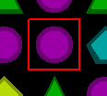 

You have 60 seconds to get a score as high as possible.

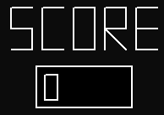

Score:

+30 when a destroyer gem pops

+25 when a flame gem pops

+20 when a destroyer gem is made

+15 when a flame gem is made

+10 when a regular gem pops

**NOTE: Resolution must be 1366x768**